**You can both using the Lattice modulo software or LCD Assistant :**

**Using the Lattice modulo software:**

1. First , you should download the Lattice modulo software here.
2. Config the setting as bellows:

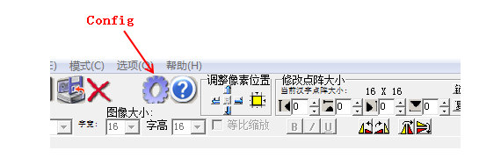

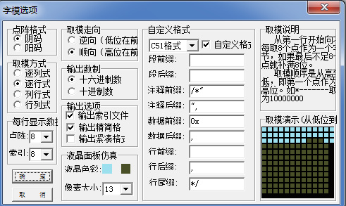

1. Then , creat a new project:

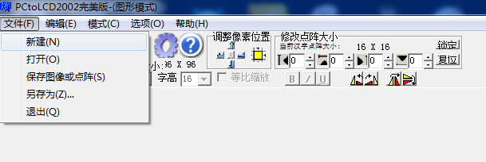

And ,set the line and column to 96x96:

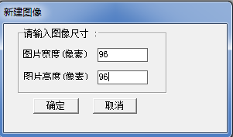

And , then OK.

1. Now, it is time to make your own image:

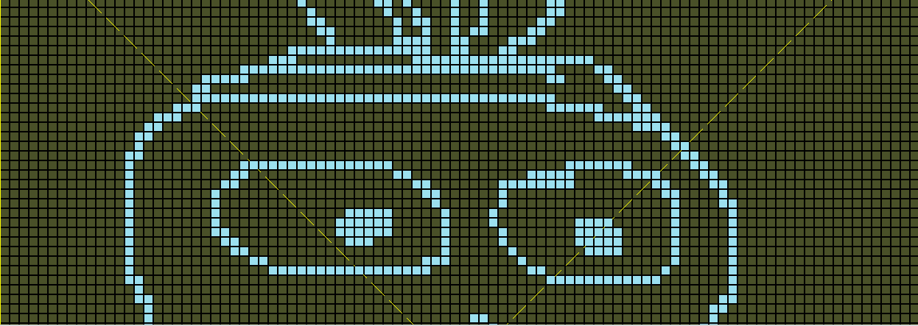

1. And , then , generates the codes and save:



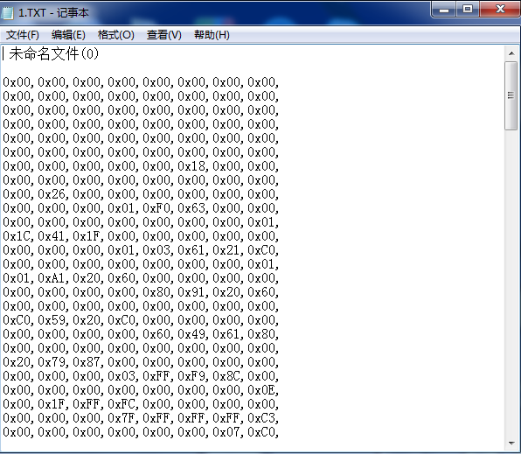

1. Copy the codes to your Arduino program. And note the last “,” should be deleted in the progam. It will works:

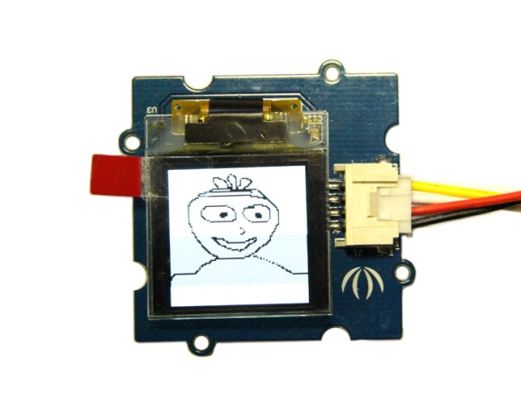

**Using the LSC Assistant:**

1. Download the software here;
2. Make you 96x96 image , for example, using the windows printer, and saves as .bmp /single bit;

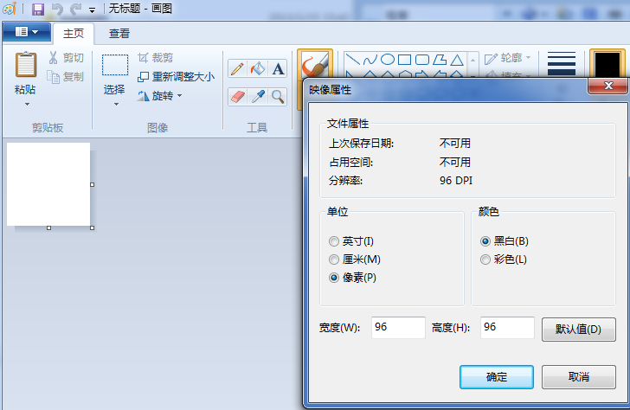

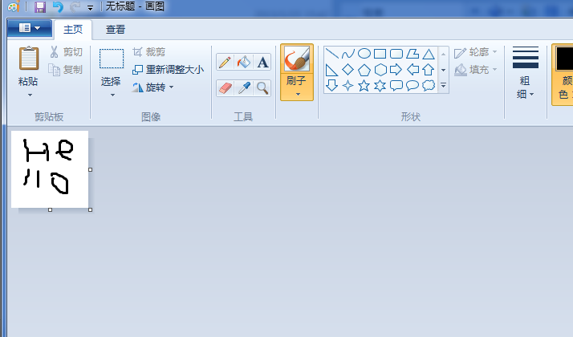

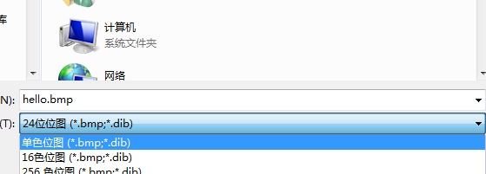

1. Load the saved image with LCD Assistant:

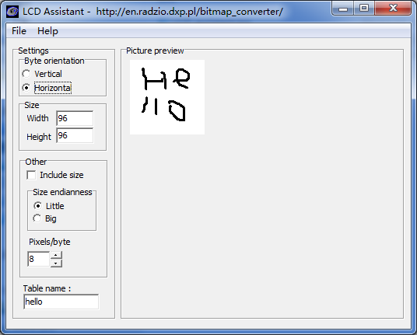

Note to set the width and height to 96.

1. And save:

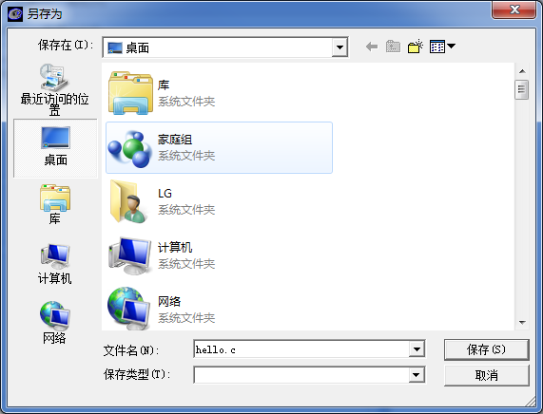

1. Open the file hello.c, you will see all the data:

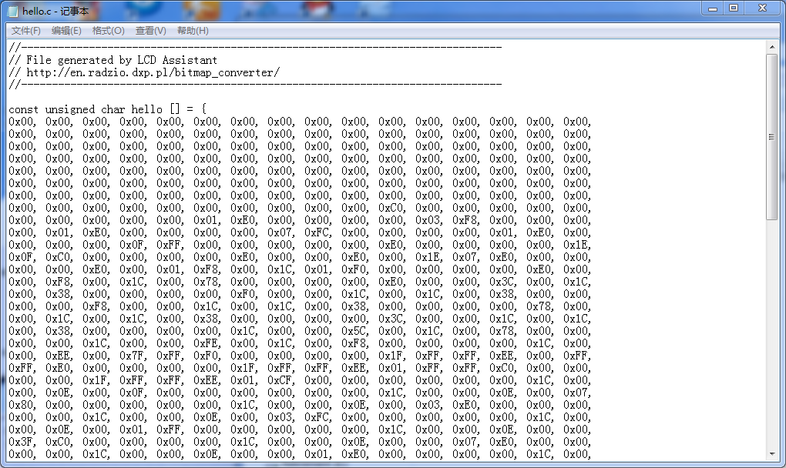

1. Copy the date to your Arduino, it will works…☺